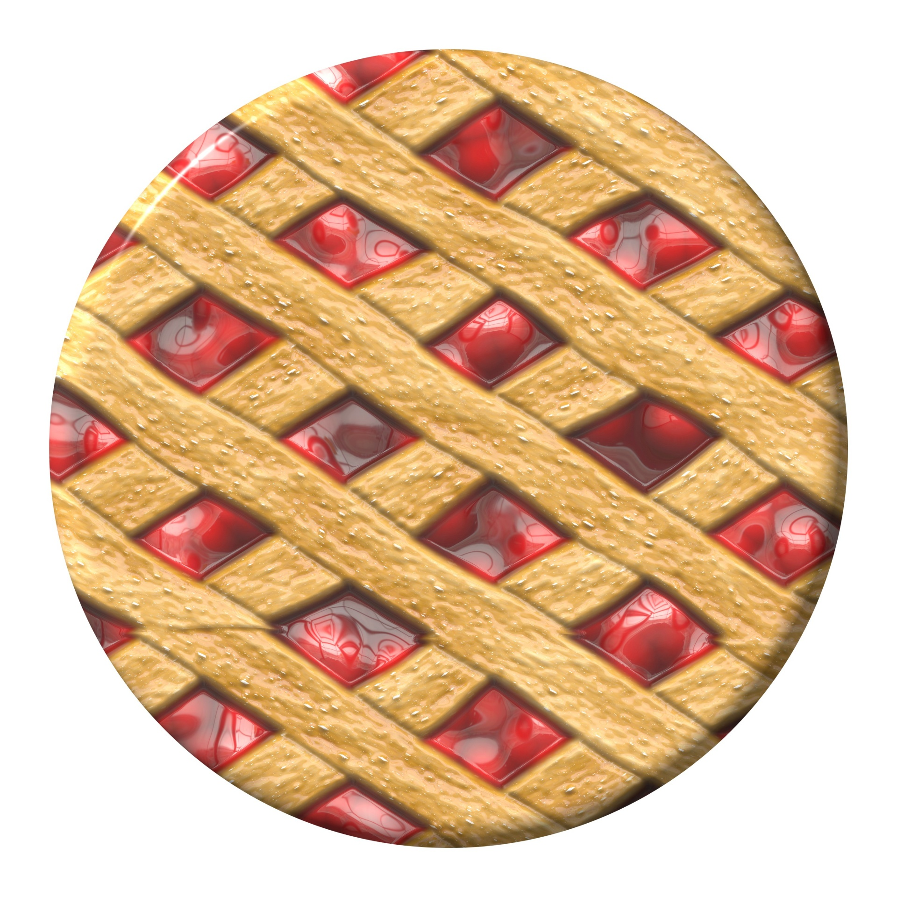

2023 Fayette County Fair Queen Pie Auction Local Support

*Proceeds go to upcoming Fair Office Renovation*

*Make Checks Payable to: Fayette Co. Ag Society Fair Queen*

* Local Support will be added to your total after the pie is purchased. You still have to have supporters in the stands to buy your pie!
* List donors in order of who gave the most to least please. Please type if possible.

|  |  |  |  |
| --- | --- | --- | --- |
| Donor’s Name/Business Name (How They’d Like it Announced) | Donor’s Contact Info/Address | Amount Donated | Pd. Check #_____ or Pd. Cash |
|  |  |  |  |
|  |  |  |  |
|  |  |  |  |
|  |  |  |  |
|  |  |  |  |
|  |  |  |  |
|  |  |  |  |
|  |  |  |  |
|  |  |  |  |
|  |  |  |  |
|  |  |  |  |
|  |  |  |  |
|  |  |  |  |
|  |  |  |  |
|  |  |  |  |
|  |  |  |  |
|  |  |  |  |
|  |  |  |  |
|  |  |  |  |
|  |  |  |  |